European Group of Pensioners

from Savings Banks and Financial Institutions

EUROMEETING 201 7– PORTO (PORTUGAL)
ROOMS RESERVATION FORM
When: from 28 MAY to 4 JUNE 2017 | Where: AXIS OFIR BEACH RESORT HOTEL (4)
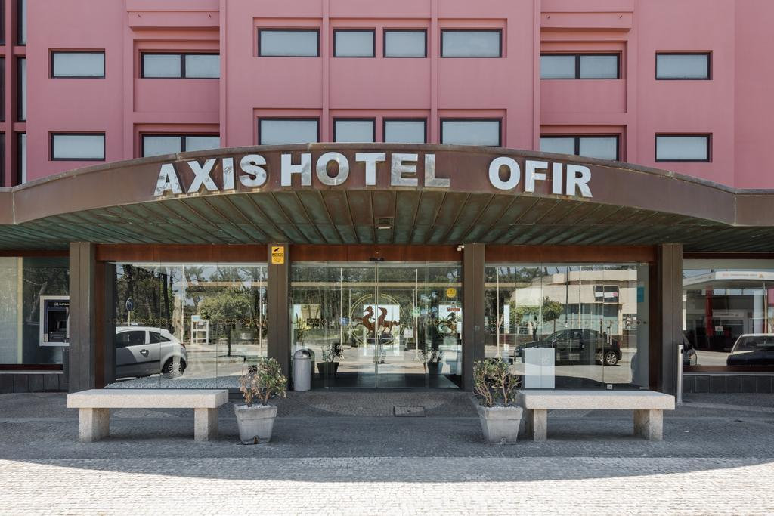 | 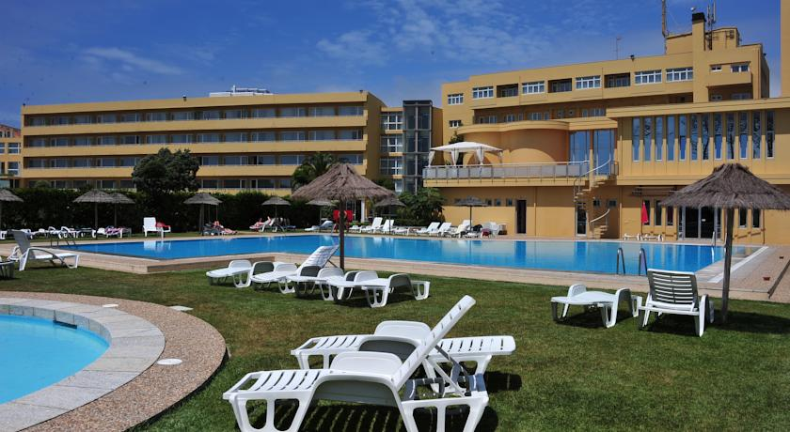

To be sent by fax or mail to the following address:
VIAJES TRANSVIA ➞ Calle San Fernando, 5 03002 Alicante (España)
 (+34) 965 14 39 50 (Department of Groups) Fax: (+34) 96 514 43 51
E-mail: euroencuentro@viajestransvia.com

Deadline is subject to availability at the time of application.
1.- Person who makes the reservation:
Name and surname(s) |  | V.A.T. r. n. | Address
Postcode | City/town |  |  | Fax / e-mail

Association of retirees:

All details must be completed.
2.- Rooms’ occupants:
Room | Name | Surname(s) | V.A.T. r. n.:  Birthdate: __/__/____ | Date of issue: __/__/____  Expiry date: __/__/____
1 | Name | Surname(s) | V.A.T. r. n.:  Birthdate: __/__/____ | Date of issue: __/__/____  Expiry date: __/__/____
Room | Name | Surname(s) | V.A.T. r. n.:  Birthdate: __/__/____ | Date of issue: __/__/____  Expiry date: __/__/____
2 | Name | Surname(s) | V.A.T. r. n.:  Birthdate: __/__/____ | Date of issue: __/__/____  Expiry date: __/__/____
Room | Name | Surname(s) | V.A.T. r. n.:  Birthdate: __/__/____ | Date of issue: __/__/____  Expiry date: __/__/____
3 | Name | Surname(s) | V.A.T. r. n.:  Birthdate: __/__/____ | Date of issue: __/__/____  Expiry date: __/__/____
The total number of available vacancies is limited. Reservations will be confirmed according to the reception dates.
3.- Price per person:
Members from associations affiliated to the European Group➞(*) Mark with an “X” the kind of room.
(*) | DOUBLE ROOM | (*) | INDIVIDUAL ROOM
 | 850,00 € |  | 1.070,00 €
Non-affiliated members➞(*) Mark with an “X” the kind of room.
(*) | DOUBLE ROOM | (*) | INDIVIDUAL ROOM
 | 880,00 € |  | 1.100,00 €
THE PRICE INCLUDES FULL-BOARD AND ALL THE TRIPS
► Mark with an “X” if you are affected by any medical intolerance to some food and/or allergies. In that case, enter your needs.IF YOU DO NOT INDICATE IT IN ADVANCE WE CANNOT GUARANTEE A PROPER PROVISION
➞ Yes ➞ No Kind: _______________________________________________________________________________________
PRICES: The trip prices have been calculated according to the currency exchange, fares, fuels, fees and VAT in force in Spain and Portugal as of 01/08/16. Any change in the mentioned fee can be revised and passed on the customer according to the current legislation, and the general conditions included in this offer and attachments (Article 157 RDL 1/2007).

4.- Offers for airline, train and coaches tickets:

ViajesTransvia has agreements with several airlines and train companies in order to provide custom fees if needed. Check the coaches’ prices that can be discounted thanks to its use in trips. Contact directly with the agency.

5.- Airport transfers: ViajesTransvia will provide them from Porto airport to the hotel and vice-versa upon request for: 25,00€ (Porto) per go and return journey and person. Very important: these prices are based on a minimum of 30 people. For further information ask us. The agency will try to gather you with other small groups as long as the time and the airport coincide. If you are interested, send the following details before the 15th of March 2017 in order to have the total foresight and to be able to provide a proper service with full information about the mean of transport you will use both for the arrival and the departure.
Transfers | Airport-Hotel: Porto: Date: Flight: Time:
Transfers | Hotel-Airport: Porto: Date: Flight: Time:

6.- Payment method:

Bank transfertoVIAJES TRANSVIA., account:SABADELLES14 0081 5228 29 0001254535 SWIFT CODE: BSAB ESBB (credit cards and cheques are not admitted)
a).-25% will be deposited before 15/12/2016, additional 25% until15.03.2017 and 50% remaining before 14/04/2017.
b).-25% will be deposited before 15/12/2016 and 75% remaining before 28/03/2017
Cancellations:
- Until the 31st of December will be penalised with 10% of the total amount.
- From the01/01/2017 to 60 days before the Euromeeting:will be penalised with 25% of the total amount.
- Between 59-20days before the Euromeeting: will be penalised with 50% of the total amount.
- Between 19-10 days before the Euromeeting:will be penalised with 75% of the total amount
- Between 9-0 days before the Euromeeting: will be penalised with 100% of the total amount.

7.- BASIC INSURANCE of assistance on arrival INCLUDED (Policy at your disposal).
COVERAGES
PROVISIONS | Other nationalities Spanish
- Medical and sanitary insurance in Europe 4.200,00€ 1.500,00€
- Companion’s repatriation, transport for deceased
insured, injured and/or ill people, relative’s journey
if admitted at hospital over 5 days , lost luggage’s INCLUDED ASK
search, location and delivery and urgent messages
transmission
- Stay expenses abroad and convalescence in the
hotel up to 10 days 30€ per day 50€ Per day
-If you wish contracting an optional trip insurance, please ask the travel agency.

8.- Services included in the price:
- Welcoming and closing cocktail.
- Basic travel insurance:
- Scheduled trips with 1 meal and 1 dinner in restaurant and tickets for the Stock Exchange Palace, Mateus (house, chapel and gardens), a wine tasting tour and meal in “Quinta de Pacheca”, the garment museum “Viana do Castelo”, the “Paço and Castelo de Guimaraes”, the cruise along the Douro river (Cruzeiro das 6 Pontes) in Porto, the wine cellar in Porto at night with a wine tasting as well as a dinner and night show in Herança Magna and tickets for the “Cathedral of Braga”.
- Multilingual local guides at destination
- Accommodation and full-board with wine and water served at table
- Interpreters,scheduled ceremonies,audio-visuals,coffee break, free Wifi in the whole hotel.
- Common expenses(secretary, documentation, translations, tourist guides).
- Not included: Journey to the hotel and return, telephone expenses, laundry, bar, etc.

9.- AXIS OFIR BEACH RESORT 4 ****  AV. Raul Sousa Martins 4740-405  Fão – Esposende (Portugal)     +351 253 989 800 www.axishoteis.com | 
...........................................................................................................................................................................................................................................
www.euroencuentros.org info@euroencuentros.org

