European Group of Pensioners from Savings Banks

and Financial Institutions
EUROMEETING 2018– SEVILLE (SPAIN)
ROOMS RESERVATION FORM
When: from 19 TO 26 MAY 2018
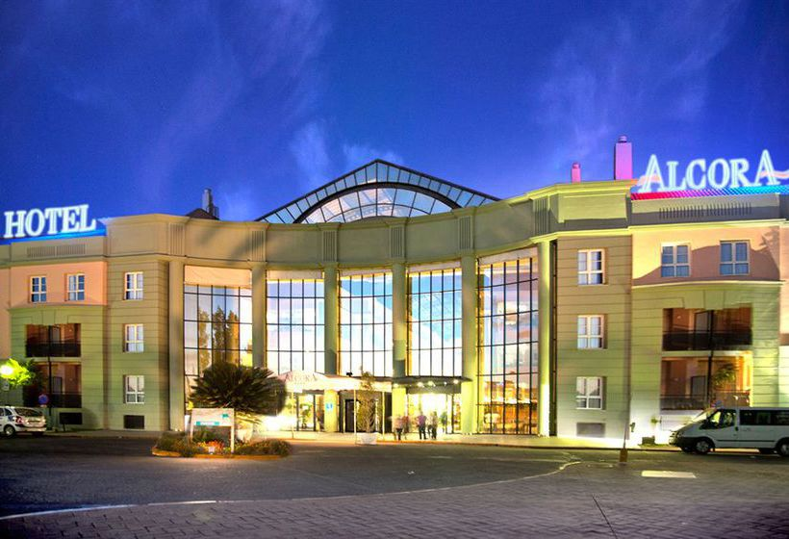 | TRH ALCORA 4 ****  Ctra.San Juan – Tomares, km, 1  41920 San Juan de Aznalfarache  (SEVILLA) España  www.trhhoteles.com  +34954349600

To be sent by fax or mail to the following address:
VIAJES TRANSVIA ➞ Calle San Fernando, 5 03002 Alicante (España)
 (+34) 965 14 39 50 (Departamento de Grupos) Fax: (+34) 96 514 43 51
E-mail: euroencuentro@viajestransvia.com

Deadline is subject to availability at the time of application.
1. - Person who makes the reservation:
Name and surname(s) |  | V.A.T.r.n. | Address
Postcode | City/Town |  |  | Fax / e-mail

Association of retirees:

All details must be completed
2.- Rooms’ occupants:
Room | Name | Surname(s) | V.A.T.r.n.  Birthdate: __/__/____ | Date of issue: __/__/____  Expiry date: __/__/____
1 | Name | Surname(s) | V.A.T.r.n.  Birthdate: __/__/____ | Date of issue: __/__/____  Expiry date: __/__/____
Room | Name | Surname(s) | V.A.T.r.n.  Birthdate: __/__/____ | Date of issue: __/__/____  Expiry date: __/__/____
2 | Name | Surname(s) | V.A.T.r.n.  Birthdate: __/__/____ | Date of issue: __/__/____  Expiry date: __/__/____
Room | Name | Surname(s) | V.A.T.r.n.  Birthdate: __/__/____ | Date of issue: __/__/____  Expiry date: __/__/____
3 | Name | Surname(s) | V.A.T.r.n.  Birthdate: __/__/____ | Date of issue: __/__/____  Expiry date: __/__/____
The total number of available vacancies is limited. Reservations will be confirmed according to the reception dates.
3.- Price per person:
Members from associations affiliated to the European Group➞(*) Mark with an “X” the kind of room.
(*) | DOUBLE ROOM | (*) | INDIVIDUAL ROOM
 | 875,00 € |  | 1.075,00 €
Non-affiliated members➞(*) Mark with an “X” the kind of room.
(*) | DOUBLE ROOM | (*) | INDIVIDUAL ROOM
 | 905,00 € |  | 1.105,00 €
THE PRICE INCLUDES FULL-BOARD AND ALL THE TRIPS
► Mark with an “X” if you are affected by any medical intolerance to some food and/or allergies. In that case, enter your needs. IF YOU DO NOT INDICATE IT IN ADVANCE WE CANNOT GUARANTEE A PROPER PROVISION
➞ Yes ➞ No Kind: _______________________________________________________________________________
PRICES: The trip prices have been calculated according to the currency exchange, fares, fuels, fees and VAT in force in Spain as of 01/08/17. Any change in the mentioned fee can be revised and passed on the customer according to the current legislation, and the general conditions included in this offer and attachments (Article 157 RDL 1/2007).

4.- Offers for airline, train and coaches tickets: ViajesTransvia has agreements with several airlines and train companies in order to provide custom fees if needed. Check the coaches’ prices that can be discounted thanks to its use in trips. Contact directly with the agency.

5.- Airport transfers: Viajes Transvia will provide them from Seville airport to the hotel and vice-versa upon request for: 15,00€ (Seville) per go and return journey and person. Very important: these prices are based on a minimum of 30 people. For further information ask us. The agency will try to gather you with other small groups as long as the time and the airport coincide. If you are interested, send the following details before the 15th of March 2018 in order to have the total foresight and to be able to provide a proper service with full information about the mean of transport you will use both for the arrival and the departure.

Transfers | Airport-Hotel: Seville: Date: Flight: Time:
Transfers | Hotel-Airport: Seville: Date: Flight: Time:

6.- Payment method:
A) BANK TRANSFER to VIAJES TRANSVIA. To confirm your attendance, you must send a copy of the bank payment indicating as concept of the transfer EUROENCUENTRO followed by your last name.
Account: SABADELL ES14 0081 5228 29 0001254535 SWIFT CODE: BSAB ESBB

B) CREDIT CARD (VISA, MASTER, etc.) Indicate:
Number: Expiry date:

a).- 25% will be deposited before 15/12/2017, additional 25% until15.03.2018 and 50% remaining before 14/04/2018.
b).- 25% will be deposited before 15/12/2017 and 75% remaining before 28/03/2017
Cancellations:
- Until the 31st of December will be penalised with 5% of the total amount.
- From 1 st of January 2018 to 60 days before the Euromeeting: will be penalised with 25% of the total amount.
- Between 59-15days before the Euromeeting: will be penalised with 50% of the total amount.
- Between 15-0 days before the Euromeeting: will be penalised with 100% of the total amount.
If the seats canceled by other new bookings are covered, the total amount minus 5% for the management and insurance costs incurred will be returned
7.-Insurance of assistance and cancellation in destiny (The detailed policy will be sent at the time of subscription).
COVERAGES
PROVISIONS | Other nationalities Spanish
- Medical and sanitary insurance in Europe 4.200,00€ 1.500,00€
- Companion’s repatriation, transport for deceased
insured, injured and/or ill people, relative’s journey
if admitted at hospital over 5 days, lost luggage’s INCLUDED INCLUDED
search, location and delivery and urgent messages
transmission
- Cancellation fees according to insurance conditions 600€ 600€

8.- Services included in the price:
- Welcoming and closing cocktail.
- Basic travel insurance.
- Excursions, meals and activities according to the advances in the program.
- Common expenses(secretary, documentation, translations, tourist guides/guides in every language from the hotel).
- Not included: Journey to the hotel and return, telephone expenses, laundry, bar, etc.
- Accommodation and full-board with wine and water served at table  - Interpreters, scheduled ceremonies, audio-visuals, coffee break, free Wi-Fi in the whole hotel. | 

www.euroencuentros.org info@euroencuentros.org

